External EPG configuration Guide

Tools needed:

* Program Postman (or similar) - postman.com/downloads/
* EPG xml file
* Internet connection
* Access to Lynk Cloud

1. **Request ID/SecKey for Token**

**ID/Key** will be provided through the UI of the LYNK Cloud portal. However, it is still in implementation, so you should make a direct request to HQ.

**SiteID** and **CompanyID** is visible after logging to Cloud and getting into Site, see above.

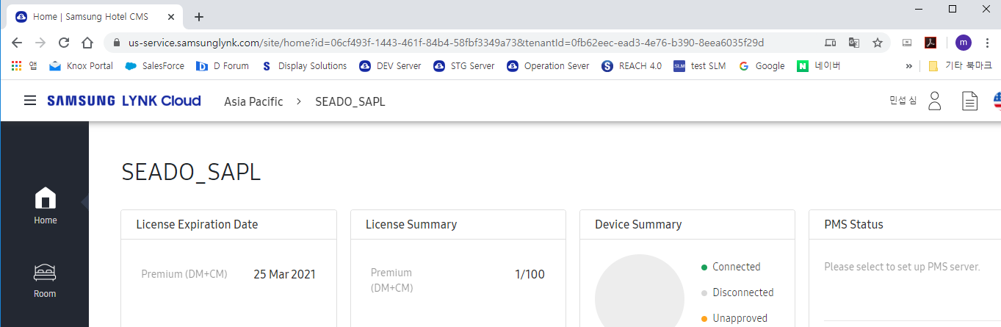

**Company ID**

**Site ID**

Temporary: To get the ID/SecKey, you should request HQ.   
Please send a mail with **Site ID** & **Company ID**, then we will share ID/SecKey.

US : [doyong1.kim@samsung.com](mailto:doyong1.kim@samsung.com), EU : [min.shim@samsung.com](mailto:min.shim@samsung.com)

1. Postman configuration for getting token:
   1. 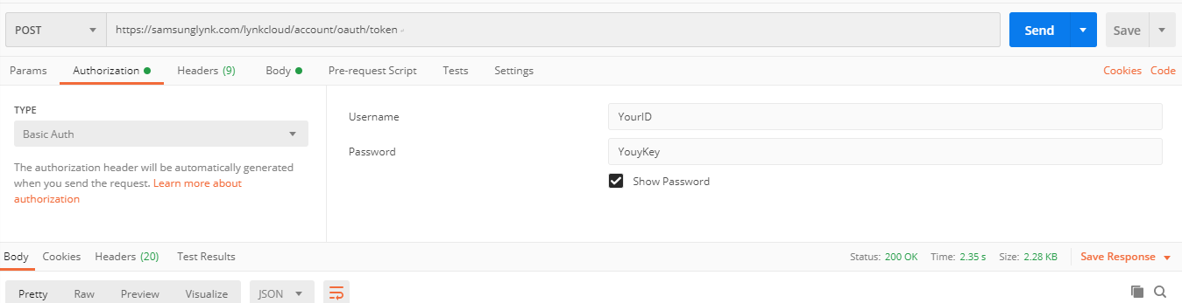
2. Select **POST** method  
   Put address [https://samsunglynk.com/lynkcloud/account/oauth/token](https://stg.samsunglynk.com/lynkcloud/account/oauth/token)  
   Click “Authorization“ tab , select **Basic Auth** in dropdown menuEnter the ID and Key, as username and password.
   1. Got to **Body** tab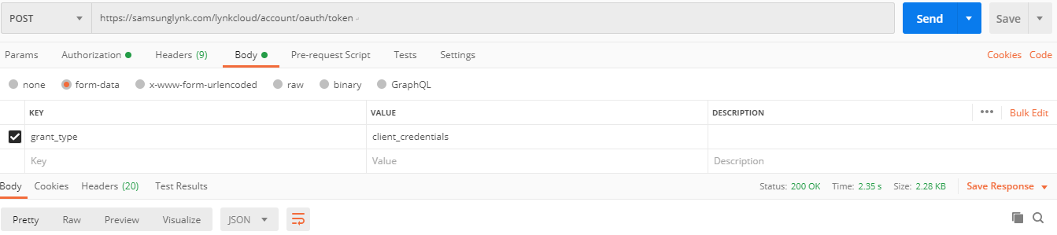  
      insert below key and value:  
      Key : **grant_type**Value: **client_credentials**
   2. Send request
   3. Copy **Access Token**, that looks like this (without brackets)  
      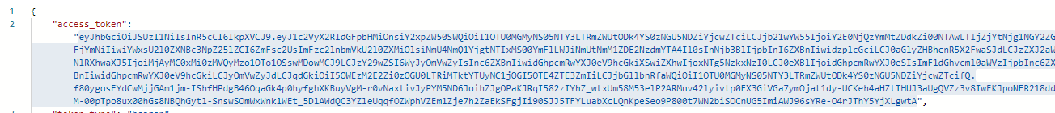
3. Create new tab in Postman
4. Select **PUT** method, and give the address:   
   [***https://www.samsunglynk.com/api/v1/sites/{siteID}/epgfile***](https://www.samsunglynk.com/api/v1/sites/%7bsiteID%7d/epgfile), where **{siteID}** is the ID taken from cloud address bar:



1. Go to Headers Tab, and insert below keys and values:

* **Content-Type** : **binary/octet-stream**
* **File-Name** : **yourEpgFile.xml (if your file has different name than put it here)**
* **Authorization** : **Bearer {access_token}**as presented:  
  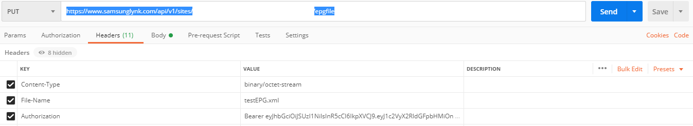

1. Go to **Body** tab  
   select **binary** button  
   upload your EPG xml file  
   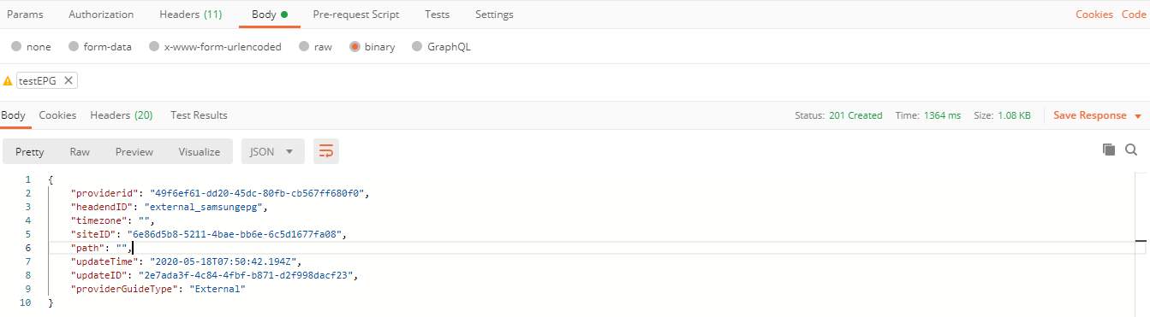
2. Click **Send**
3. Login to cloud lynk and go on Site.
4. Go to Device>Channel Map
5. Click Program Guide Settings and chose External from dropdown  
   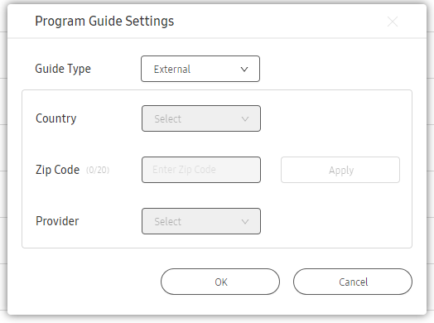
6. If your EPG file was correct, it is possible to choose EPG from the list in your channel map:  
   