Edge Server Installation Guide

[Squid proxy server]

|  |  |  |  |
| --- | --- | --- | --- |
| **Project Name** | LYNK Cloud | | |
| **Date** | 2020.Jan.16 | **Version** | Version 0.9 |
| **Author** | Jinliang Wang | **Approver** |  |
| **Team** | VD Enterprise SW Lab | | |

Contents

Edge Server Test Guide 1

[Squid proxy server] 1

1. System Requirement 3

1.1. Microsoft Windows 3

1.2. Ubuntu Linux 3

2. Download and install squid 3

2.1. Version 3

2.2. Install Squid for windows. 3

2.3. Install Squid for Ubuntu. 4

3. Copy intermediate CA 5

4. Copy configurations for squid 6

4.1. Copy configurations 6

4.2. Test configuration change 6

5. Generate cache folder and start Squid. 7

5.1. Generate cache folder for windows. 7

5.2. Generate cache folder for ubuntu. 8

6. Edge server setting on LYNK Cloud 9

6.1. Set address of Edge Server 9

6.2. Clicking ‘Apply’ makes CMS app. refers to Edge Server 10

7. Proxy working test 10

7.1. Test Procedure 10

7.1.1. Download LYNK Cloud app. from SmartHub 10

7.1.2. Launch LYNK Cloud app. 11

7.1.3. Traverses LYNK Cloud app. menus/content to store the content into the Edge server 11

7.1.4. Check squid access log. 11

7.1.5. Uninstall LYNK Cloud app. from TV 12

7.1.6. Download LYNK Cloud app. from SmartHub again 12

7.1.7. Launch LYNK Cloud app. and traverse the LYNK Cloud app. menus. 12

7.2. Check Squid access log. 12

8. [Appendix] Test on PC 13

8.1. You can test squid by add proxy for IE by Settings->connections->LAN settings. 13

8.2. Access some web pages in web browser, the web pages can be visited. 14

9. [Appendix] Generate certificate for squid from hospitalitysolutionCA 14

9.10. You can find cache files under C:\Squid\var\cache\squid (windows) or /usr/local/squid/var/cache/squid (ubuntu). 17

# System Requirement

## Microsoft Windows

* + - Microsoft Window 7 (64bit)
    - Microsoft Windows 10 (64bit) -- Tested by Dev. team
    - Microsoft Window Server 2016

## Ubuntu Linux

* + - Ubuntu 14.04 LTS
    - Ubuntu 16.04 LTS – Tested by Dev. team
    - Ubuntu 18.04 LTS
    - Ubuntu 18.10

# Download and install squid

## Version

LYNK Cloud Edge Server feature has been tested with Squid version 3.5.x

## Install Squid for windows.

* + 1. **Download Squid from** [**http://squid.diladele.com/**](http://squid.diladele.com/)



* + 1. **Click the msi file and install Squid.**

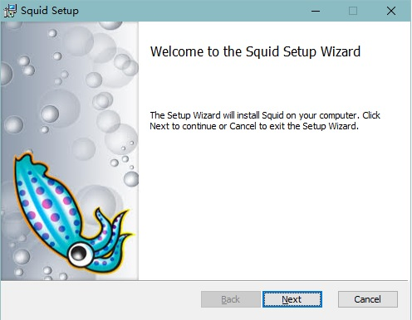

After installing, there’s two icons appears on the desk, Squid Terminal and Squid Server Tray.

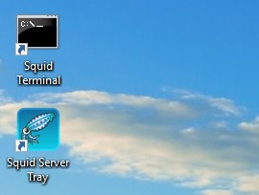

## Install Squid for Ubuntu.

* + 1. **Download squid install files from** [**http://www.squid-cache.org/Versions/v3/3.5/squid-3.5.28.tar.gz**](http://www.squid-cache.org/Versions/v3/3.5/squid-3.5.28.tar.gz)
    2. **Copy squid-3.5.28.tar.gz to ubuntu folder and extract file with below command**

|  |
| --- |
| tar xvf squid-3.5.28.tar.gz |

* + 1. **Enter folder squid-3.5.28.tar.gz, configure compiling with the below command.**

No error should be shown.

|  |
| --- |
| ./configure --with-openssl --enable-ssl-crtd |

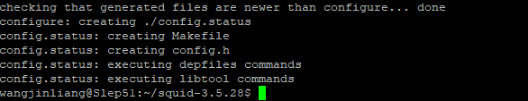

* + 1. **Install squid with the following command.**

|  |
| --- |
| sudo make install |

It will take time to install. And no error should be shown.

Squid will be installed to folder /usr/local/squid.

* + 1. **Change folder authority and make necessary folders with the below command.**

|  |
| --- |
| sudo chmod -R 777 /usr/local/squid/  mkdir /usr/local/squid/ssl_cert  chmod 777 /usr/local/squid/ssl_cert |

* + 1. **Init ssl_db with the below command.**

|  |
| --- |
| cd /usr/local/squid/libexec/  sudo ./ssl_crtd -c -s /usr/local/squid/var/cache/ssl_db -M 4MB  sudo chmod -R 777 /usr/local/squid/var/cache/ssl_db |

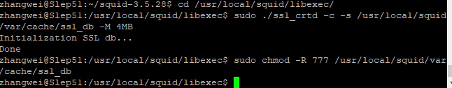

# Copy intermediate CA

* 1. Please copy the separately shared secondCA.key and secondCA.pem to

{Squid Installed Directory}/etc/squid (windows) or /usr/local/squid/ssl_cert (Ubuntu).

# Copy configurations for squid

## Copy configurations

Please copy the separately shared squid.conf to

{Squid Installed Directory}/etc/squid/squid.conf (windows) or

/usr/local/squid/etc/squid.conf (Ubuntu)

## Test configuration change

For windows, double click Squid Terminal and input the command “squid -k parse”, if no error appears, it means all your changes above is good. For ubuntu, go to folder “

/usr/local/squid/sbin”, and input command “sudo ./squid -k parse”

Windows

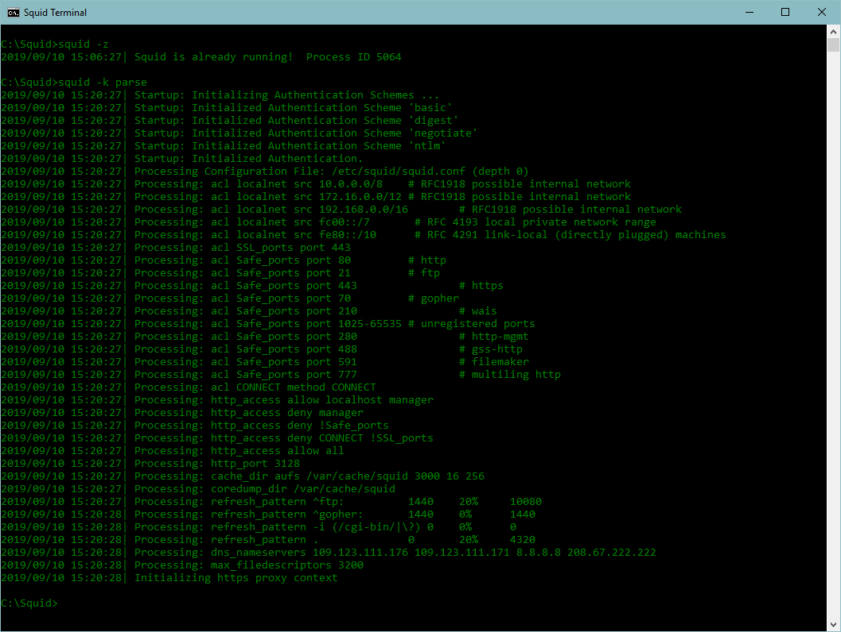

Ubuntu

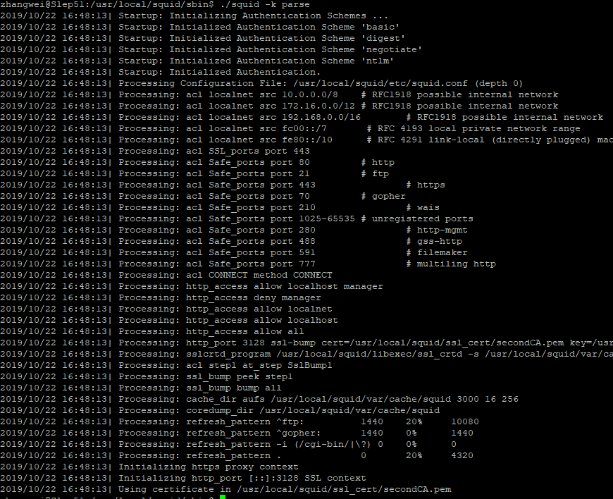

# Generate cache folder and start Squid.

### Generate cache folder for windows.

* + 1. Right click the Squid service Icon in the taskbar, choose stop Squid service. Then delete all files under C:\Squid\dev\shm.

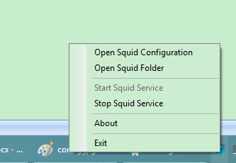

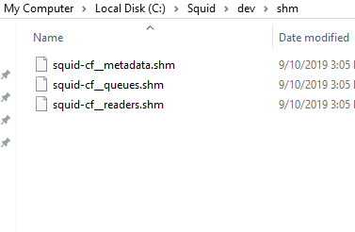

* + 1. Input “squid -z” in squid Terminal, then you can see many folders in C:\Squid\var\cache\squid.

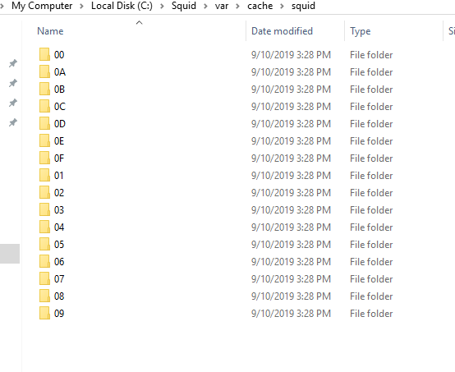

* + 1. Right click the Squid Server Tray and click “start squid service”

### Generate cache folder for ubuntu.

* + 1. Go to folder /usr/local/squid/sbin, input command “sudo ./squid -z”, you will see many folders under /usr/local/squid/var/cache/squid.

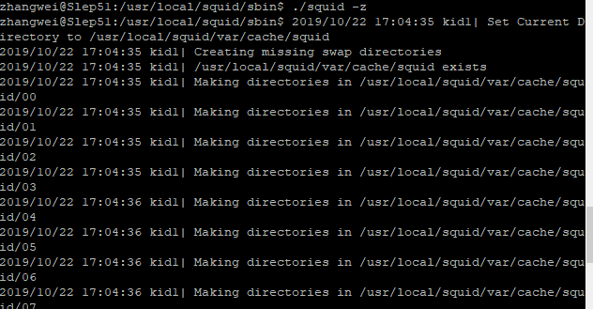

* + 1. Go to folder /usr/local/squid/sbin, input command “sudo ./squid -s” to start squid service.

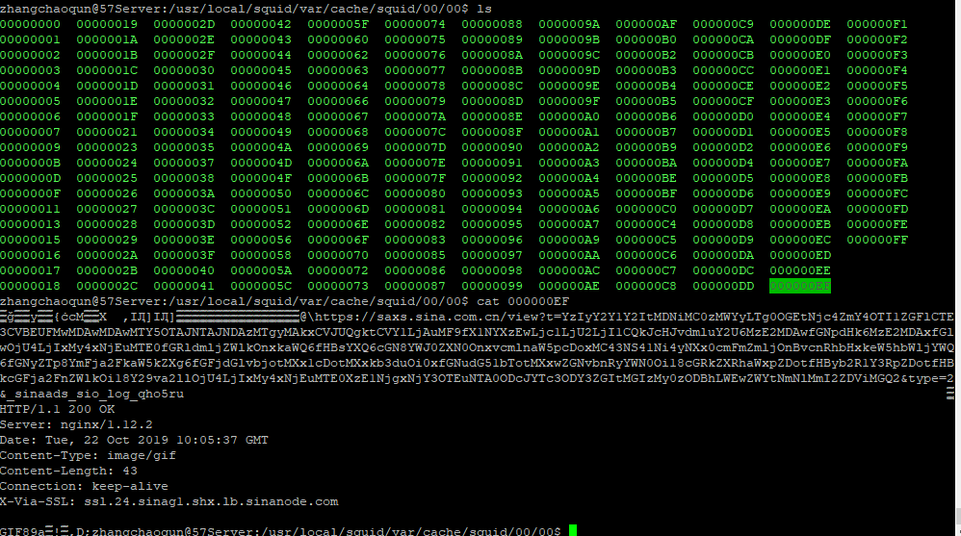

# Edge server setting on LYNK Cloud

### Set address of Edge Server

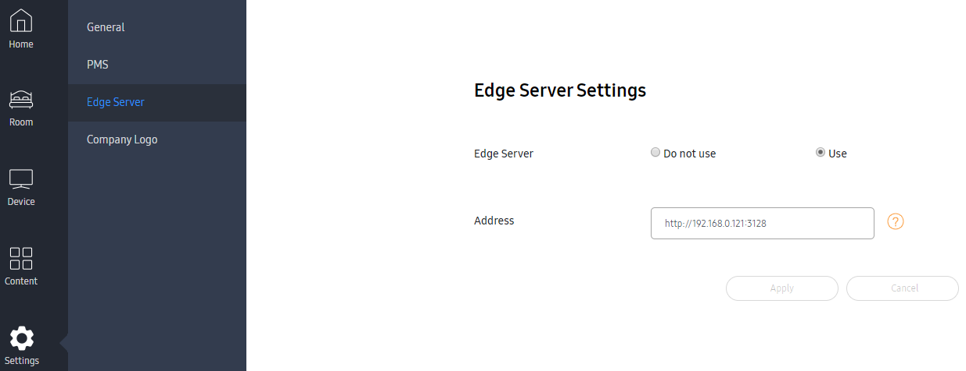

Please set an Edge server address like “http://192.168.0.121:3128”

You must change IP address to your edge server IP.

3128 is a port number which is written in squid.conf (http_port 3128 ssl-bump)

### Clicking ‘Apply’ makes TV CMS app. refers to Edge Server

# Proxy working test

Squid proxy server returns the cache content when clients request the same page/content.

Cache content lifecycle depends on lifecycle setting as per the contents of content servers. Lifecycle is managed by Cache-Control header in CMS pages.

### Test Procedure

1. Download LYNK Cloud app to TV.
2. Launch the app. and traverses CMS menus to store CMS images into Edge server.
3. Check Squid server program log.
4. Uninstall LYNK Cloud app and install the app again.
   1. The current CMS webpages are configured to keep all the images in TV local webbrowser.
   2. So once LYNK Cloud app. has traversed the CMS menus on the web page, it does not queries the images to CMS content server again.
5. Launch App. and traverses the same menus to retrieval cached CMS images.
6. Check Squid server program log to check ‘HIT’

### Download LYNK Cloud app. from SmartHub

First you have to enable appstore access in an eden bar through

TV admn menu > Control > Smart Service > App Editable > On

After that you can download LYNK Cloud app. in TV Eden Bar > Appstore > LifeStyle > LYNK Cloud

### Launch LYNK Cloud app.

### Traverses LYNK Cloud app. menus/content to store the content into the Edge server

The Edge Server internally store LYNK Cloud content into the Edge Server storage for future content access from LYNK Cloud App.

### Check squid access log.

You can see ‘TCP_MISS/200’ messages for jpg files. It means those images are not cached.

|  |
| --- |
| 1573175530.977 1062 192.168.0.130(TV IP) TCP_MISS/200 396464 GET <http://13.75.120.30:8080/tv-content/images/home/dining/dining_inhotel_img06.jpg> - HIER_DIRECT/13.75.120.30 image/jpeg  1573175531.540 1415 192.168.0.130 TCP_MISS/200 274566 GET http://13.75.120.30:8080/tv-content/images/home/dining/dining_inhotel_img07.jpg - HIER_DIRECT/13.75.120.30 image/jpeg  1573175532.899 437 192.168.0.130 TCP_MISS/200 88473 GET http://13.75.120.30:8080/tv-content/images/home/dining/dining_inhotel_img12.jpg - HIER_DIRECT/13.75.120.30 image/jpeg  1573175532.915 2637 192.168.0.130 TCP_MISS/200 325109 GET http://13.75.120.30:8080/tv-content/images/home/dining/dining_inhotel_img09.jpg - HIER_DIRECT/13.75.120.30 image/jpeg  1573175534.626 1806 192.168.0.130 TCP_MISS/200 245921 GET http://13.75.120.30:8080/tv-content/images/home/dining/dining_inhotel_img13.jpg - HIER_DIRECT/13.75.120.30 image/jpeg  1573175542.836 6692 192.168.0.130 TCP_MISS/200 440556 GET http://13.75.120.30:8080/tv-content/images/home/dining/dining_nearby_img01.jpg - HIER_DIRECT/13.75.120.30 image/jpeg  1573175546.236 8110 192.168.0.130 TCP_MISS/200 323507 GET http://13.75.120.30:8080/tv-content/images/home/dining/dining_nearby_img02.jpg - HIER_DIRECT/13.75.120.30 image/jpeg  1573175552.544 552 192.168.0.130 TCP_MISS/200 206903 GET http://13.75.120.30:8080/tv-content/images/home/dining/dining_nearby_img05.jpg - HIER_DIRECT/13.75.120.30 image/jpeg  1573175552.836 9571 192.168.0.130 TCP_MISS/200 447016 GET http://13.75.120.30:8080/tv-content/images/home/dining/dining_nearby_img03.jpg - HIER_DIRECT/13.75.120.30 image/jpeg  1573175556.383 25891 192.168.0.130 TCP_MISS/200 1567646 GET http://13.75.120.30:8080/tv-content/images/home/dining/dining_inhotel_img10.jpg - HIER_DIRECT/13.75.120.30 image/jpeg |

### Uninstall LYNK Cloud app. from TV

The current CMS webpages are configured to let browsers (LYNK Cloud app) keep all the CMS images in local TVs when the CMS images are once retrieved by browsers. (HTTP Cache-Control spec.)

So once LYNK Cloud app. has traversed the CMS menus on the web pages, it does not download the CMS images again when the app. open the same pages.

In order to test the cache function, here, we need to uninstall the existing LYNK Cloud App. to delete local cache images.

Another testing way is to prepare one more TV set then the second LYNK Cloud app. will retrieve the cached images from the edge server.

### Download LYNK Cloud app. from SmartHub again

### Launch LYNK Cloud app. and traverse the LYNK Cloud app. menus.

### Check Squid access log.

* + 1. **Check access.log under folder “C:\Squid\var\log\squid” (Windows) or /usr/local/squid/var/logs (ubuntu), you can search key word ”HIT”, that means squid cached the file and return directly.**

|  |
| --- |
| 1573196311.747 3238 192.168.0.130 TCP_MEM_HIT/200 291865 GET http://13.75.120.30:8080/tv-content/images/home/dining/dining_inhotel_img01.jpg - HIER_NONE/- image/jpeg  1573196314.883 3453 192.168.0.130 TCP_MEM_HIT/200 440408 GET http://13.75.120.30:8080/tv-content/images/home/dining/dining_inhotel_img04.jpg - HIER_NONE/- image/jpeg  1573196317.095 274 192.168.0.130 TCP_MEM_HIT/200 171415 GET http://13.75.120.30:8080/tv-content/images/home/dining/dining_inhotel_img05.jpg - HIER_NONE/- image/jpeg  1573196318.930 7644 192.168.0.130 TCP_MEM_HIT/200 357071 GET http://13.75.120.30:8080/tv-content/images/home/dining/dining_inhotel_img02.jpg - HIER_NONE/- image/jpeg  1573196321.042 81 192.168.0.130 TCP_MEM_HIT/200 30543 GET http://13.75.120.30:8080/tv-content/images/home/local-area/localarea_tour_002_BestSeoul.jpg - HIER_NONE/- image/jpeg  1573196321.233 9948 192.168.0.130 TCP_MEM_HIT/200 394096 GET http://13.75.120.30:8080/tv-content/images/home/dining/dining_inhotel_img03.jpg - HIER_NONE/- image/jpeg  1573196323.524 203 192.168.0.130 TCP_MEM_HIT/200 49935 GET http://13.75.120.30:8080/tv-content/images/home/local-area/localarea_tour_001_FullDay.jpg - HIER_NONE/- image/jpeg  1573196324.800 14 192.168.0.130 TCP_MEM_HIT/200 28325 GET http://13.75.120.30:8080/tv-content/images/home/local-area/localarea_tickets_001_Lotte.jpg - HIER_NONE/- image/jpeg  1573196325.770 12 192.168.0.130 TCP_MEM_HIT/200 24547 GET http://13.75.120.30:8080/tv-content/images/home/local-area/localarea_tickets_002_Alive.jpg - HIER_NONE/- image/jpeg |

Basically dynamic content is not cached to a proxy server.

It’s defined by content metadata when CMS content is created.

|  |
| --- |
| 192.168.0.120 TCP_MISS/200 284 GET https://bam.nr-data.net/1/f82aff6731? - HIER_DIRECT/162.247.242.19 text/javascript |

Javascript result can be different even the request is the same. It cannot be cached to proxy server. You can see many TCP_MISS for javascripts in the access.log.

|  |
| --- |
| 192.168.0.120 TCP_MISS/200 223168 GET https://dev-editor.samsunglynk.com/testing/wp-content/uploads/sites/174/2019/11/ripley-zoo-unsplash-2.jpg? - HIER_DIRECT/192.0.66.200 image/webp  192.168.0.120 TCP_MISS/200 284 GET https://bam.nr-data.net/1/f82aff6731? - HIER_DIRECT/162.247.242.19 text/javascript |

GET with ‘?’ character in request header means that it is a query to server, the return value can be different as per backend server logic even the request is the same. In the case, TCP_MISS will be produced.

|  |
| --- |
| 192.168.0.120 TCP_IMS_HIT/304 352 GET https://dev-editor.samsunglynk.com/testing/_static/? - HIER_NONE/- text/css |

But this case we can estimate the return value seems to be the same. It returns TCP_HIT.

Squid proxy server follows HTTP standard for cache control. A content providing side (content web page) specifies cache or not, cache life time, and so on.

So the cache HIT result can be very various as per content sites.

# [Appendix] Test on PC

### You can test squid by add proxy for IE by Settings->connections->LAN settings.

Google Chrome browser is an official web browser for LYNK Cloud. Chrome browser refers to IE Proxy Setting.

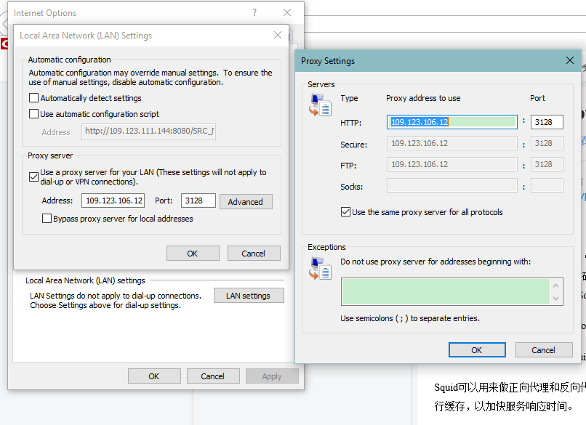

### Access some web pages in web browser, the web pages can be visited.