**\*\* how to get your client id, secret**

1) enter this web site

https://console.developers.google.com/

2) login and choice your project (if you don't have, please make it)

3) enable CalDAV API, Calendar API

APIs & auth

* APIs

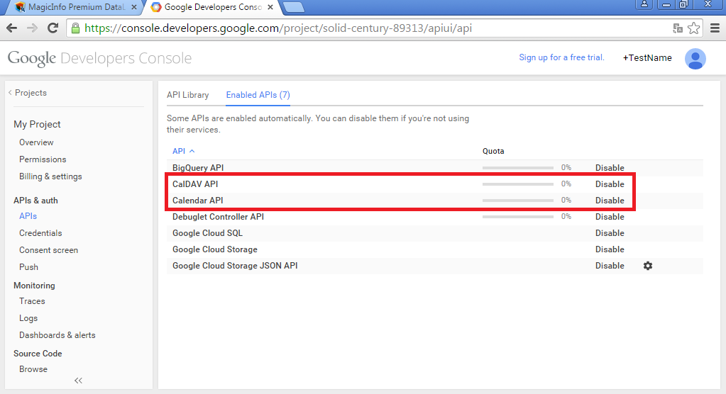

4) APIs & auth

- Credentials

get your client id, secret (if you don't have, please make it)

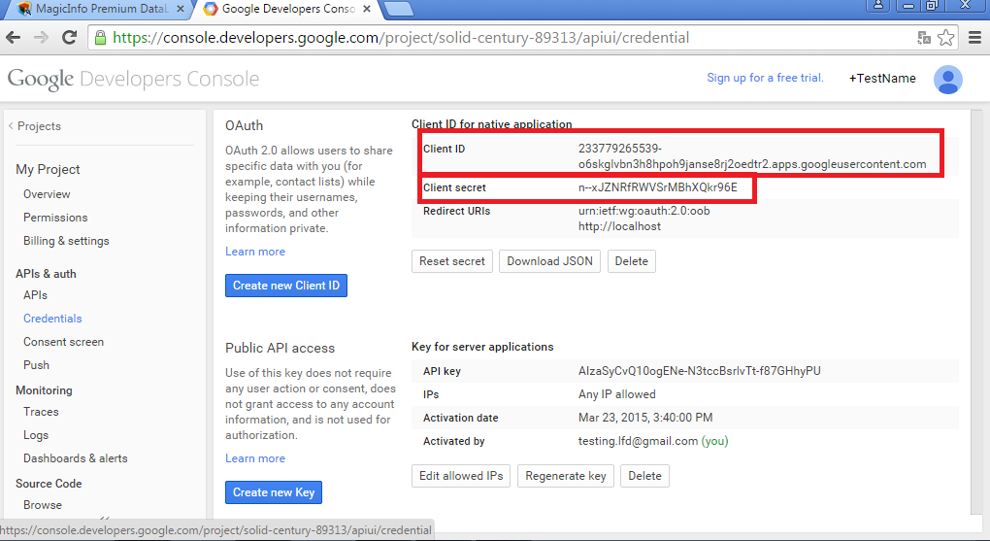

5) Accept your account

Open your browser, access this URI (on the DataLink Server PC)

https://accounts.google.com/o/oauth2/auth?client_id=ClientID&redirect_uri=http://localhost:9089/Callback&response_type=code&scope=https://www.googleapis.com/auth/calendar

ex)

https://accounts.google.com/o/oauth2/auth?client_id=16238543-2glpq55c947qel5ols5ftffq9ema6upv.apps.googleusercontent.com&redirect_uri=http://localhost:9089/Callback&response_type=code&scope=https://www.googleapis.com/auth/calendar

* Click Accept Button

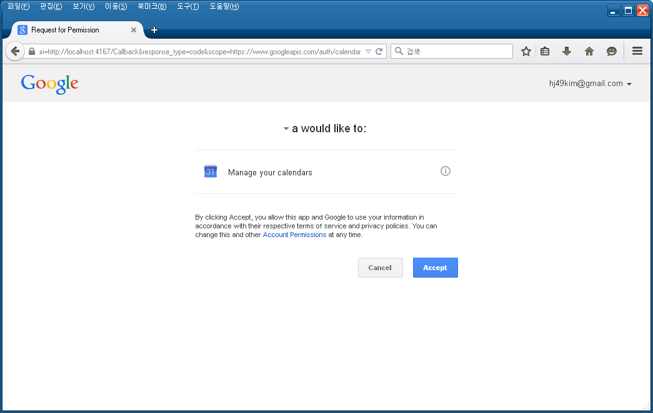

If you can’t access this url,

Please open your log file,

(C:\MagicInfo DataLink\Tomcat\logs\ magicinfo_premium_datalink-stdout.*.log)

and just copy and paste google url to your browser’s url input box.

**\*\* how to add new service**

